Medical Engineering:
Ultrasound Diagnosis Sensor and its Preamplifier

Name: | Matrikelnummer:
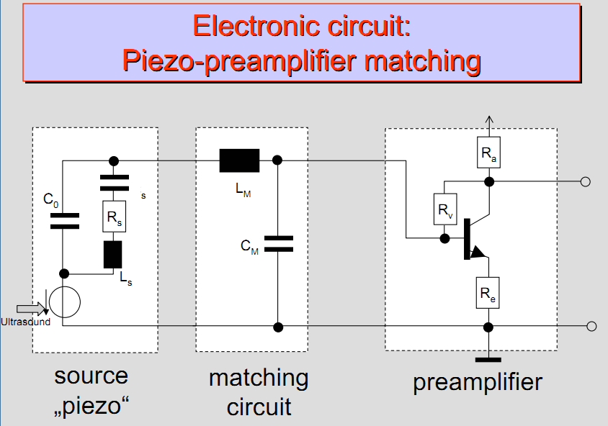
Part 1: Introduction to PSpice analysing a low-pass filter 1st order
Activities: First steps in the simulation software "LTspice" by analyzing a low-pass filter
1st order. Usage, drawing circuits, setting of simulation command and display of plots and diagrams.
Aim: Knowledge about simulation of electrical circuits using numerical methods as "SPICE". Understanding of basic analyzing tools as Nyquist Plot and Bode Diagram for validation of frequency response in electrical systems.
Analysis: Operating-point-analysis and AC-analysis with graphical display of the Nyquist plot and Bode diagram
Part 2: Frequency Response of an ultrasound piezo-crystal using an RCL-model
Activities: Drawing of electrical circuit corresponding to a model of a piezo crystal. Nyquist plot of the electrical impedance and validation of the impedance at ultrasound transmitting frequency f_{T} = 2MHz
Aim: Validation of a source impedance of a sensor at a certain frequency using AC-analysis and Nyquist Plot with possibilities of cursor measurements.
Analysis: Operating-point-analysis and AC-analysis with graphical display of the Nyquist plot and cursor measurements
Part 3: Frequency Response of a low-pass filter 2nd order as a matching filter for impedance transformation
Activities: Drawing of electrical circuit and profile setting for parameter variation of a resistive load using Bode Diagram of the voltage-transfer-function.
Aim: Simulation of electrical circuits by numerical methods using "LTspice". Understanding of the basic methods using a Bode Diagram for frequency transfer function of an electrical system.
Analysis: Bias-point-analysis and AC-analysis with graphical display of the Bode diagram
Part 4: Preamplifier and matching to the sensor "piezo"
Activities: Drawing of the electrical circuit of a transistor-preamplifier and analyzing the circuit with a sinusoidal source signal (2 MHz) with validation of the input impedance of the preamplifier. Matching of the input impedance by variation of the "emitter"-resistance of the transistor.
Aim: Understanding of basic analysis in time domain using sinusoidal signals with current and voltage measurements. Matching of the input impedance by variation of a certain resistor.
Analysis: Bias-point-analysis and time domain-analysis with graphical display over time and cursor measurements.

Low-pass filter 1st order

Drawing electrical circuit
At first, please generate a new schematic like shown in Figure 1.1.
Use the “LTspice Getting started” or the “LTspice_Qick” manual for reference.
Please use the parts “voltage”, “R”, “C” and “Ground” and mark the lines by node-with names ("in" ; "out") for better orientation
In addition, add some function definitions to calculate input impedance and admittance
and set up an AC-Analysis from 1Hz to 1MHz with 101 points / decade.
Fig. 1.1:: Electrical circuit of the low-pass filter of the 1st order / function
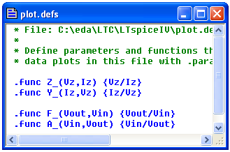

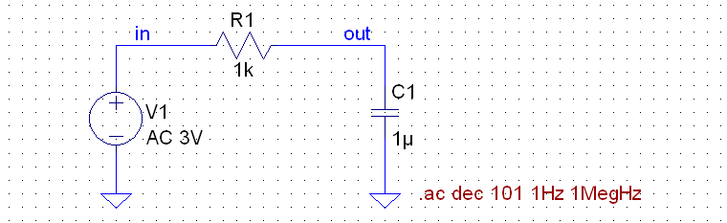

Simulation of the input impedance of the low-pass filter
Please create a XY-diagram (Bode Plot) of the input impedance and its phase. Add some function definitions to the plot definitions file via Plot Settings | Edit Plot Defs File.
Display “Z” in a logarithmic scale (not in dB) and ensure that the graphs are not congruent with the axes, by adjusting the vertical axis settings !
Find the cut-off frequency with the cursors and mark the points using the Annotations menu.
Fig. 1.2: Documentation: xy-diagram of the input impedance
Please check, if the phase
of the impedance is correct !
( Z = R + 1/jωC → phase must be negative at low frequencies)
Now create the Nyquist plot of the input impedance Z of the filter by changing the representation mode in the left vertical axis settings dialog.
Add comments / arrow to show the run of the curve and mark frequencies 0Hz and infinite.
Fig. 1.3: Documentation: Nyquist plot for the input impedance

Further on, please generate a Nyquist-plot of the input- admittance Yin = 1/Zin of the low pass filter. Please add comments / arrow to show the run of the curve and mark frequencies 0Hz and infinite.
Try to find the cut-off frequency with the cursor and mark this point via the menu
| Plot Settings | Notes & Annotations | Label Curs. Pos. |
Fig. 1.4: Documentation: Nyquist plot for the input admittance

Simulation of the transfer function and display as a Bode Diagram
Please add a directive for the transfer function F = U_{out} / U_{in} in the plot definition file and document the Bode Diagram within the specified frequency range (1Hz to 1MHz).
Try to create two separate plots, one for the magnitude and one for the phase of the transfer function and label the frequency with φ = -45° in the diagrams using cursor measurements.
Fig. 1.5: Bode diagram of the low-pass filter 1st order

Value for the upper cutoff-frequency: ω_{cu} |{ φ = 45°} =

Frequency response of the piezo-crystal using RCL-model

Drawing the electrical circuit model for piezoelectric crystal
Draw the electrical circuit model of the ultrasound crystal.
Please label input line of the model by net-name "in" for better orientation.
Fig. 2.1: Electrical circuit / model of the ultrasound crystal
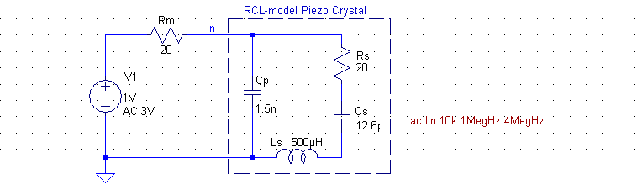

Simulation of Piezo impedance around its characteristic frequency
Please define a the SPICE-directive (simulation command) for a linear AC-analysis from 1MHz to 4MHz and create an XY-diagram for Z_{crystal} and its phase over frequency.
Fig. 2.2: Documentation - crystal impedance over frequency
Is the phase shown correct ?
( must be -90° for ω ->0 and ω -> ∞!)
Show the magnitude in a linear way (not in dB) and zoom in a range of
~ ±50kHz around the characteristic frequencies.
Measure the serial and parallel resonance frequencies with the cursors.
Copy the plot inclusive the cursor-window for documentation and label the cursors with “fs” / “fp”. (use the draw functions of your text editor)
Measure the impedance at the serial resonance frequency for the phase φ  = 0°, where the optimum power is transmitted to the preamplifier.
Cursor-measured Value: Z_{c} |{ f_{s} = MHz} = Re{Z_{c}} + j Im{Z_{c}} = Ω + j0 Ω
In addition please generate a Nyquist-plot (Gaussian plain) of the crystal-impedance Zc.
Measure the resonance frequencies with the cursors and copy the plot inclusive the cursor-window for documentation.
Fig. 2.3: Documentation: Nyqist plot of the crystal impedance
Please refine the documentation with your text procession tool:
- label the cursors with “fs” / “fp”
- add some arrows to show how the curve runs
- add labels for ω → 0 ; ω → ∞

Frequency response of a low-pass filter 2nd order

Drawing of the electrical circuit
At first generate a new schematic called "LowPassFilter2" that will be used to adopt a load of 700Ω to the ~24Ω impedance of the ultrasound crystal, at the frequency of 2MHz.
- Please calculate the theoretical values for L and C of the matching filter. (spread sheet ?)
- Try to use values from the E12 series for the components.
- You may use two capacitors in parallel tow get a more precise result.
Please label input and output line by net-names "in" and "out" for better orientation.
For the following measurements around this resonance frequency please use an average value from the theoretical 2MHz and the one determined in Chapter 2.
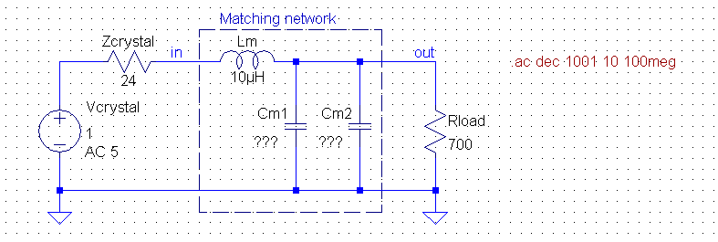
Fig. 3.1: Electrical circuit for simulating low-pass filter 2nd order
Calculation of the transfer network components:
- Create Formular for Zin
- Separate the real and the imaginary parts
- calculate Cm (imaginary part is zero at resonance freq.)
- calculate Lm

Analysis of the low-pass filter 2nd order
Please set up a simulation command for an AC-analysis from 10Hz to 100MegHz with 1001 points/decade and document the result for the input impedance of the filter in Bode-diagram.
Fig. 3.2: Bode Diagram showing the input impedance of the filter with magnitude / phase
Please check, if the phase
of the impedance is shown correct !
( Z_{in}|_{ω → ∞} = R_{load} + jωL_{f} → phase must be → +90° at high frequencies)
Show the magnitude in a logarithmic way (but not in dB) and zoom in a range of
10kHz to 100MegHz
Measure at the resonance frequency of the Piezo-crystal with the cursor and copy the diagram inclusive the cursor-window for documentation.
In addition document the transfer function of the matching filter in the frequency range from 100kHz to 100MHz.
Fig. 3.3: Bode Diagram showing the filters transfer function in dB and its phase.
Zoom in a range of 100kHz to 100MegHz. Measure at the crystals resonance frequency with the cursor and copy the plot inclusive the cursor-window for documentation.
Please measure the amplification by cursor at the crystals resonance frequency.
Cursor-measured Value: ´F |{ f = MHz} = dB ≡
Please note the input impedance resonance frequency by cursor from Fig. 3.2 for the
crystals resonance frequency with magnitude and phase.
Cursor-measured Value: Z_{in} |{ f_{s} = MHz} = |Z_{in}| * e^{jφZin} = Ω * e^{j °}

Preamplifier and matching to the sensor for f ~ 2MHz

Drawing of electrical circuit
For Transistor Q1 we want to use a “BFQ67” for which there is no model available in the LTspice standard libraries. Therefore you have to add a file with the model description to the folder where your schematic is located ( source: ..\Labor\Introd_Ultrasound/BFQ67.mod )
Then place a “NPN” transistor, change its value to “BFQ67” and add a SPICE directive to include the new model. (.include BFQ67.mod)
Label interesting lines by net-names "in", "out", "base" and "filter..." for better orientation. Note that the values of the component models for Crystal and Filter are still the ones figured out by previous examinations.
Please check your circuit by running a first operating-point simulation. Modify the value of R_{v} to get a V_{out} of about V_{cc}/2. Use a “preferred number” from the “E12 series” please !
Fig. 4.1: Electrical circuit for simulating preamplifier based on the transistor
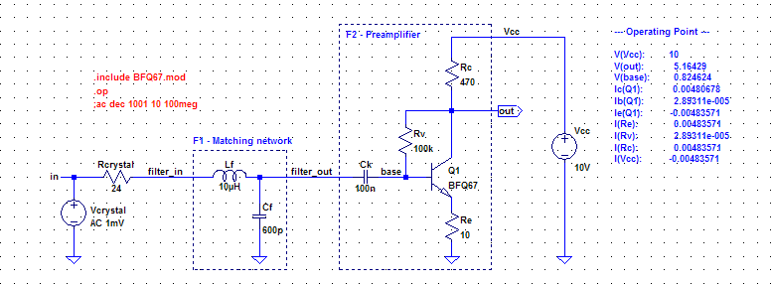
Rv =
As an overview to frequency response create the transfer function of both modules in the measuring chain. Module F1 is the matching filter and module F2 corresponds to the transistor amplifier. Set up an AC-analysis from 10Hz to 100MegHz with 1001 points/decade.
Fig. 4.2: Bode Diagram of the different stages (F1,F2) of the measuring chain.
Create the transfer function for V(out) / V(filter_in)
Mark the stages in the diagram using your text processor tool ...
At the resonance frequency fr ≈ 2MHz :
- The matching filter F1 approximately amplifies the signal for dB
- and the transistor stage F2 by the value of dB
Please calculate from the dB – values to normal factors:
F₁|_{dB} = dB ≡ F₁ =
F₂|_{dB} = dB ≡ F₂ =

Analysis of the measuring chain at frequency f=2MHz using time domain analysis
Based on the documented results (Bode Diagram) of chapter 4.2 these values have to be checked by applying time domain signals (sinusoidal 2MHz-signal with amplitude 1mV).
Further on the matching of the filter has to be approved.
Therefore please create a simulation command for time domain-analysis (Transient) for about 10 periods of the resonance frequency. Take care not to forget of the signal settings for the signal source "V_{crystal}".
Fig. 4.3: Time domain signals at the nodes in, filter_in, filter_out, and out.
Please arrange all the signals in different plot panes ( |Plot Settings| Add Plot pane| )
Fig. 4.3 shows the results of several time signals at the different nodes "in", "filter", and "out". By measuring the ratio of the different signal amplitudes the amplification factor of the modules F1 and F2 can be calculated.
For the determining the peak-to-peak values of the voltage signals, you may use the method to quickly measure differences with the mouse cursor.
If you drag the mouse as if you were going to zoom, the size of box is displayed on the status bar. You can measure differences in this manner without performing the zoom by either pressing the [Esc] key or right mouse button before releasing the left mouse button.
Please add the measured peak to peak values to your diagram above (Fig. 4.4)
F₁ = U_{filter_out} / U_{filter_in} = / = ≡ F1|dB = dB
F₂ = U_{out} / U_{filter_out} = / = ≡ F₂|_{dB} = dB

Analysis of the matching status / improvements by variation of Re
Based on the above documented results in time domain at the frequency f_{r} 2MHz the situation of correct matching of the sensor can be checked.
Using the signals shown below, please calculate the input-impedance of the matching filter and the load of the matching filter (input-impedance of the transistor amplifier).
Is there a mismatching ?
Fig. 4.5: Voltage and current trace for calc. of impedance values to check matching grade
Use two plot panes, one for filter and one for amplifier.

Add the calculations with the tools of your text processing software.
Please try to evaluate a optimized value for R_{e} for closer matching. (use preferred value -E12)
To speed up this process you may switch to a parametric (“.step ...”) AC-analysis.
optimized Values: R_{e} = Ω Z_{in}|_{F1} = Ω * e^{j °}

